pmp 2016 certification from simplilearn

introduction

project management is about getting work done and has been around for a very long time in one form or another.

Eg

Railways in America

Pyramids in Egypt

Each of these are project

2 father of project management

1 Henry gantt

The father of planning and control technique who is famous for his use of gantt chart tool for project managment

2 henri fayol

created the five managment functions that form the foundation of the body of knowledge associated with project management

breakdown structure and resource allocation

AFTER 1950 project management tools are developed

Mathematical project scheduling models

1 critical path method

2 program evaluation review technique or pert

At same time technology were evolving

1 cost estimating

2 cost management

3 engineering economics

in 1969 pmi institute was formed

pmi publishes a guide to the project management body of knowledge called pmbok guide

A project is a temporary endeavour resulting in something unique.

It is temporary because it has a definite beginning and definite end.

project creates something unique that is not a part of your daily routine, day to day operations

project management is the application of knowledge , skills tools and techniques to project activities to meet the project requirements.

This is accomplished by the application of 47 logically grouped project management process, which are categorized into five process groups.

1 initiating

2 planning

3 executing

4 monitoring and controlling

5 closing

project management knowledge areas are

1 integration

2 scope

3 time

4 cost

5 quality

6 human resource

7 communications

8 risks

9 procurement

10 stakeholder management

Project management brings a unique focus shaped by the goals, resources and schedule of each project.

Pmi and pmp credentials are world most recognized and sought after project management certification

Project manager are

Organized, passionate and goals oriented.

There are only 5k pmps in countries

Project managers are change agents they make project goals there around and use their skills and expertise to inspire the project team

They enjoy challenges and responsibility to drive business

They work well under pressure

Project manager cultivate the people skills needed to develop the trust, communication.

5.33

And leadership . pmp is more important and in every country

Pmp earn 20% more

Projects complete

On time, on budget

Five exam domains

1 initiating

Planning

Executing

Monitoring

Closing

10 knowledge areas also

2nd video

pmi: project management institute

pmp: project management professional

pmi is an organization; pmp is a credential

pmi writes and supervises the pmp examinations

pmp credentials is valid for 3 years

it can be renewed

pdu: professional development unit

you can acquire pdus different ways like attending class by an expert then you get one pdus

if you write topic on paper related to management and you can get one more pdu

pmi has important data related to pdus

pmbok a quide to the project managment body of knowledge

it is required for pdus

application requirement

bachelar degree

pm training 35 contact hours

hours leading and project tasks 4500 hours

months of pm experience : 36 months with in last 8 consecutive years

application can be submitted online

once fees paid you will get authorization letter

some application are randomly selected for audit

examination must be taken with in a year after receiving authorization letter

more details www.pmi.org

1.5 guidelines

Become pmi member before pmp submit

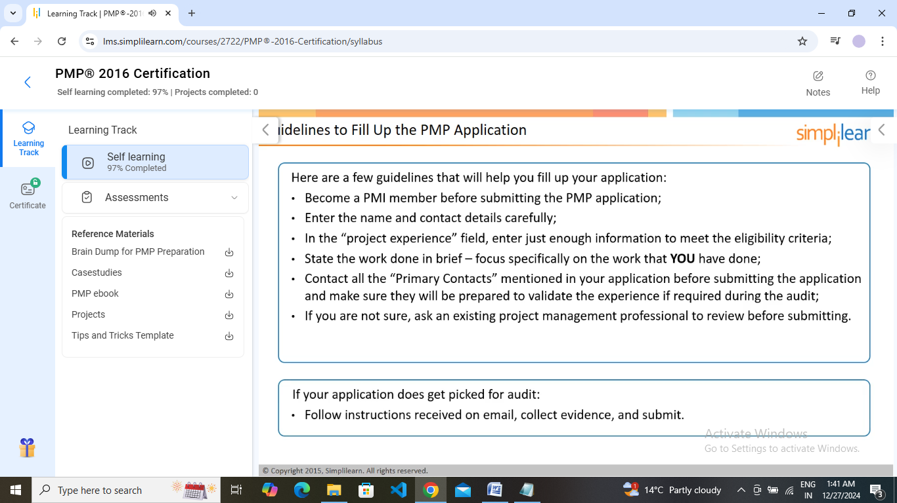

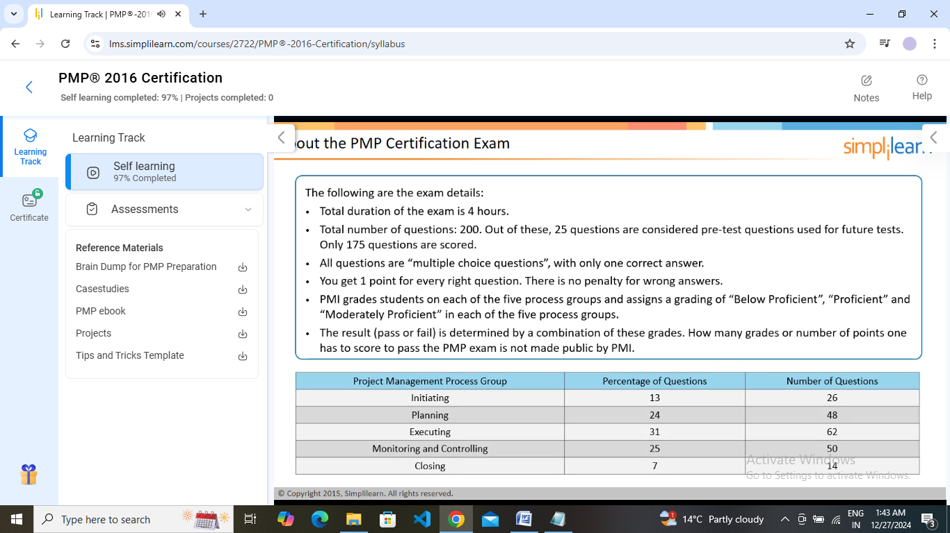

Project management is divided into following

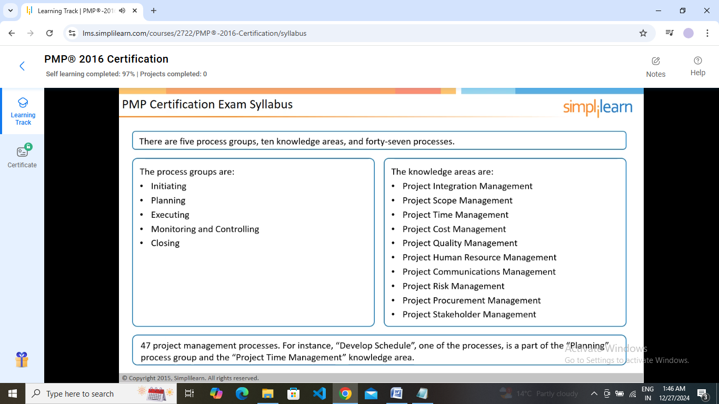

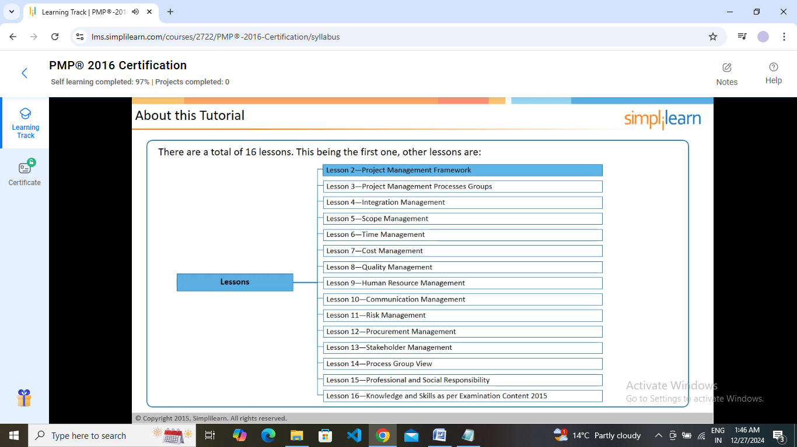

Lesson2

**Project management framework**

After completing this

You will be able to

Define project, project management, program management and portfolio management

Recognize the roles of project management office

Identify the project constraints and their impact on the project

Explain the role of a project manager in stakeholder management.

Describe different organization structure.

Differentiate between a project life cycle and a product life cycle

2.3

A project is a temporary endeavor undertaken to create a unique product, service or result

Like constructing a building, industrial plant or infrastructure and implementing, improving or enhancing existing business processes and procedures.

A project has several characterstics

Project is a temporary in nature, but has a definite start and end date

Project produces a unique output. The output can be a product,service or result.

A project comes to end when

Its objectives are met

The sponser decides to terminate the project as the objectives cannot be met or are no longer required.

Project work is different from operational work. Operations consists of ongoing , repetitive work.

Like receptionist

Eg of project is to create a software to handle customer complaints.

The definition of project management is as follows

Project management is performed by applying and integrating 47 project managem ent processes, which are logically grouped into five process groups.

Project management activities

Managing a project requires the following three steps

1. Identifying project requirements
2. Managing stakeholders
3. Balancing project constraints

(sc ope, cost, risk, time, quality, customer satisfaction)

2.7

Program management

The definition of program management is as follows

It is the application of knowledge, skills, tools and techniques to a program to meet the program requirements and in order to obtain benefits and control not available by managing projects individually.

A program is defined as a group of related projects , subprograms and program activities managed in a coordinated way to obtain benefits not available from managing them individually.

Following are the features of program management

For a group of projects to be classified as a program, there must be some value added in managing them together as a program.

A project need not belong to a program, a program will always have projects.

A program is designed to deliver some strategic benefits to the organization; the benefits could be tangible(i.e growing the operating margin) or intan gible ( eg improving the morale of the team).

A project manager focuses on fulfilling the requirements of a project, where as a program manager focuses on delivery of benefits to the organization.

Portfolio

Definition of portfolio is as follows:

A collection of projects, programs, sub-portfolios, and operations managed as a group to achieve strategic objectives.

Projects and programs of a portfolio may not be necessarily interdependent or directly related.

A portfolio can be based on the business objectives.

Eg

‘japanese projects ’ can be a portfolio where an it company puts all its projects from japan to give more focus and attention to its Japanese projects, and grow its japanese business.

Similar projects can be managed as a program within this portfolio; all banking projects will be managed as a banking program.

Portfolio management

The definition of portfolio management is as follows:

Portfolio management refers to the centralized management of one or more portfolios to achieve strategic objectives.

Portfolio management includes identifying, prioritizing, authorizing, managing and controlling projects, programs and other related work to achieve strategic business objectives.

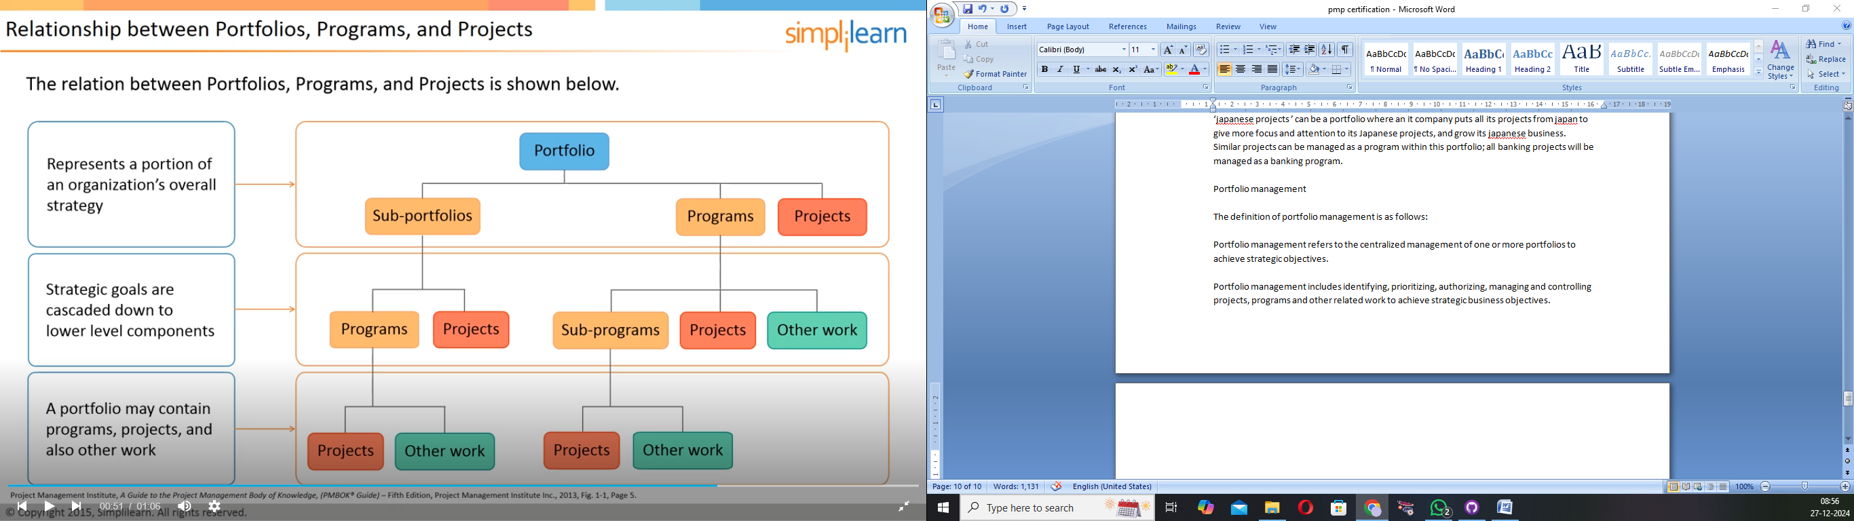

Other work comprises training, develop men t , support and so on

Project management office

A project management office (pmo) is a specific type of body, or department, within an organization.

The roles of pmo as follows:

Primary roles

Pmo usually has one or a combination of the following three primary roles:

1 It provides the policies,methodologies, and tools and templates for managing projects with in the organization.

2 it provides support and training in the organization on how to manage projects.

3 it provides project managers for ongoing projects in the organization.

Other roles

Pmo may also help in the following areas:

1 managing interdependencies between projects.

2 selecting, managing and deploying shared or dedicated project resources.

3 terminating projects.

4 organizing lessons- learned sessions.

5 maintaining the project management knowledge base for an organization.

Any project can be completed easily if there is lot of time and budget available but unfortunately this is not happened.

Managing the triple constraints

Project constraint are summarized

The following balances project manager have to do

1 time, cost, scope

2 time , cost,scope, quality

3 people , stakeholder,risk, communication, procurement

In pmp exam

Business scenario based questions on the triple constraints can be expected.

2.14

Stakeholder

The definition of stakeholder is as follows:

An individual , group or organization who may affect, be affected by , or perceive itself to be affected by a decision, activity or outcome of a project.

The project team, project manager, project sponser, PMO office, customer etc are the stakeholders of the project.

A project sponsor is the one who gives a go ahead for a project and provides the necessary resources to execute the project.

Stakeholder management

A key responsibility of a project manager is to manage stakeholders. Project manager has to take up specific activities for stakeholder management.

1 identifying internal and external stakeholders : identifying stakeholders at the beginning is essential. A stakeholder, who is identified towards the end of the project, may come up with a new requirement at that stage, and incorporating them can be risky.

2 determining stakeholder requirements : stakeholder requirem ent need to be clearly identified. It is the job of the project manager to get them right by doing a proper stakeholder requirement analysis.

3 determining stakeholder expectations: unstated stakeholders expectations need to be clarified to see if it needs to be a project requirement.

4 communicating with stakeholders: the project manager, as part of stakeholder analysis should focus on communicating them regularly to keep stakeholders involved in the project.

Tip: understand the practices of stakeholder management to answer scenario based questions.

Organization structure

The different organization structures, based on the level of authority vested in the project manager, are as follows:

Functional organization

The organization is grouped by areas of specialization within different functional areas (eg marketing, accounting, engineering etc)

Each employee reports to a functional manager.

Projectized organization

Project manager has lot of control in this

The organization’s resources mostly work on projects.

The project manager has complete control over the resources.

Matrix organization

(employee has two bosses)

This is a blend of functional and projectized structures.

The resources report into the functions, but may also work on projects. There may be weak matrix, strong matrix and balanced matrix organizations.

Team member belong to department and project manager

If functional manager has more authority on team member then weak matrix

If project manage has more authority then strong matrix

If equal authority then balanced matrix

Tight matrix: co located team. Ie. A team that has been placed in the same location in order to enhance their performance.

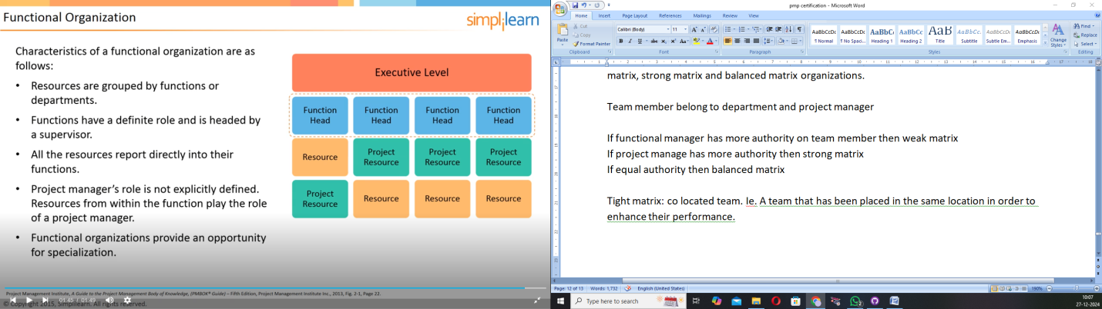

In functional chances of expertise more in specific field like all the purchases access to the purchaser and so o n.

Difficult of project manager survive

Project manager has no authority on resource may be part time project manager is there.

Projectized

Loyalty to project of resources

Disadvantage

Skills are not properly utilized like purchase manager needed for a specific period of time.

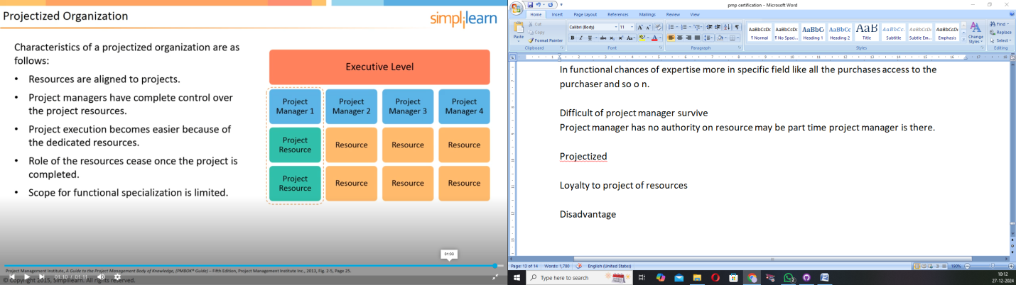

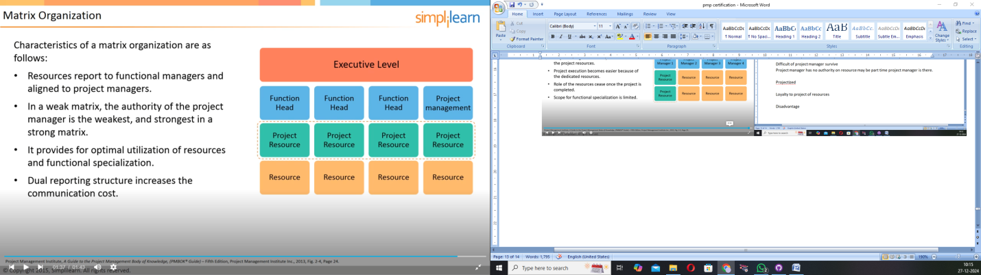

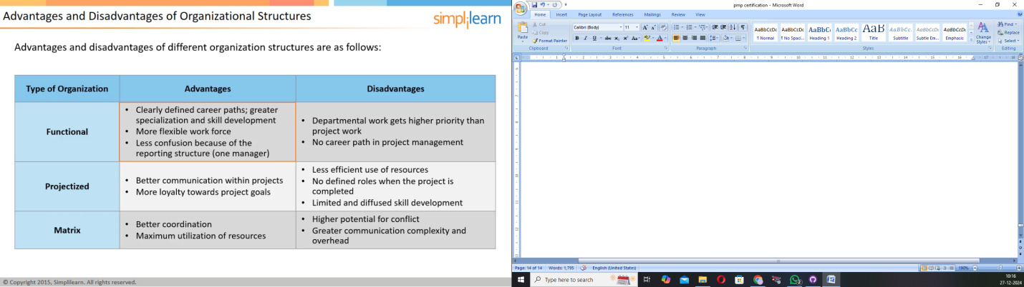

Project lifecycle vs product lifecycle

Project life cycle spans the initiation of a project un till the closure, while product life cycle encompasses the operational and maintenance phases.

A typical product life cycle starts with the conception of the product and goes until its withdrawal from the market or when it becomes obsolete

Product has a long life cycle; it can require or spawn many projects over its life.

A project life cycle depends upon the control needs of the performing organization or the organization’s preference defined in their project execution methodology.

The ability to differentiate between product and project lifecycle may be useful while answering the exam.

Project life cycles

The phases of a lifecycle represent a discrete unit of work to be completed on the project. There are various classifications of project lifecycles.

Sequential or overlapping phases

1. In sequential phases, the subsequent phase starts only after the previous phase has been completed.
2. In overlapping phases, two or more phases can run in parallel for some time.

Predictive life cycle (or plan driven)

1. Scope, cost and time are determined in advance or as early as possible.
2. The project is executed in a series of sequential or overlapping phases.
3. These are suitable for large projects where most requirements are known at the beginning of the project.
4. Each phase focuses on different activities and may require different skill sets.

Iterative and incremental life cycles

The high level objective may be defined up-front, but the details are defined in each iteration.

Product is developed through a series of such cycles.

In iterative and incremental life cycles, project phases intentionally repeat themselves.

Adaptive( or agile) life cycles

These are also incremental and iterative, but the iterations are very rapid(2 to 4 weeks)

They are generally preferred when dealing with a rapidly changing environment.

Summary

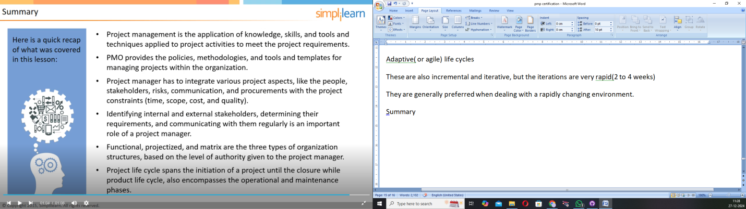

Project management is the application of knowledge, skills and tools and techniques applied to project activities to meet the project requirements.

Pmo provides the policies, methodologies and tools and templates for managing projects with in the organizations.

Project manager has to integrate various project aspects, like the people, stakeholders,risks,communication, and procurements with the project constraints(time,cost,quality and scope)

Identifying internal and external stakeholders, determining their requirements and communicating with them regularly is an important role of a project manager.

Functional, projectized and matrix are the three types of organization structures, based on the level of authority given to the project manager.

Project life cycle spans the initiation of a project until the closure while product life cycle, also encompasses the operational and maintenance phases.

Lesson 3

Project management processes